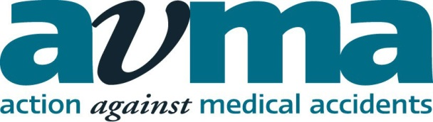
Medico-legal Issues in Plastic Surgery
27 March 2014
Pannone LLP, Manchester
Morning Chair: Sally Hatfield QC, Barrister, Byrom Street Chambers (Confirmed)
09:15 Registration
10:00 Chair’s opening remarks
10:10 Medico-legal issues in breast surgery – negligent & non-negligent surgery
- breast augmentation
- breast reduction
- mastopexy
- breast reconstruction
- consent issues
Mr Hiroshi Nishikawa, Consultant Plastic, Reconstructive & Aesthetic Surgeon, Birmingham Children’s Hospital & the Queen Elizabeth Hospital (confirmed)
11:10 Refreshments
11:25 Medico-legal issues in facial surgery – negligent & non-negligent surgery: Consent issues and managing expectations
- rhinoplasty
- otoplasty
- facial rejuvenation surgery, fillers, chemical peels
- cosmetic injections, botulinum toxin and who is licensed to inject it
- scarring
Mr Kenneth Graham, Consultant Plastic Surgeon, Whiston Hospital NHS (Trust Regional Plastic Surgery & Burns Unit), Liverpool (Confirmed)
12:25 Consent Issues and Consent Law
Sally Hatfield QC, Barrister, Byrom Street Chambers (Confirmed)
13:25 Lunch
Afternoon Chair: Raymond Machell QC, Barrister, Byrom Street Chambers (confirmed)
14:15 Medico-legal Issues in the Surgery of Melanoma and Skin Malignancies
- an overview of the types of melanoma and skin malignancies
- the effect of a delay in diagnosis and need for more extensive surgery
- negligent and non-negligent surgery
Mr Gary Ross, Consultant Plastic Surgeon, BMI Alexandra Hospital, Cheshire (Confirmed)
15:15 Refreshments
15:30 Medico-legal Issues in Abdominoplasty/Scarring, Burns and Pressure Sores
- abdominoplasty
- liposuction
- pressure sores
- scarring
- burns
Mr Azhar Iqbal, Consultant Burns and Plastic Surgeon, Whiston Hospital NHS Trust (confirmed)
16:30 Chair’s closing remarks
16:40 Close of Conference
SRA & APIL: 5 hours
Bar Council: To be confirmed

